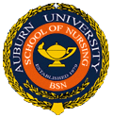

**References**

* Bergman, D. (2011). Preventing recurrent cerebrovascular eventsin patients with stroke or transient ischemic attack: The current data. *Journal Of The American Academy Of Nurse Practitioners, 23*(12), 659-666. doi:10.1111/j.1745-7599.2011.00650.x

Dontje, K. (2008). Evidence-Based Practice: Understanding the Process. *Advanced Practice Nursing eJournal, 7*(4).

* Feng, W., Hendry, R., & Adams, R. (2010). Risk of recurrent stroke, myocardial infarction, or death in hospitalized stroke patients. *Neurology, 74*(7), 588-593. doi:10.1212/WNL.0b013e3181cff776
* Lawrence, M., Fraser, H., Woods, C., & McCall, J. (2011). Secondary prevention of stroke and transient ischemic attack. *Nursing Standard, 26*(9), 41-46.



  

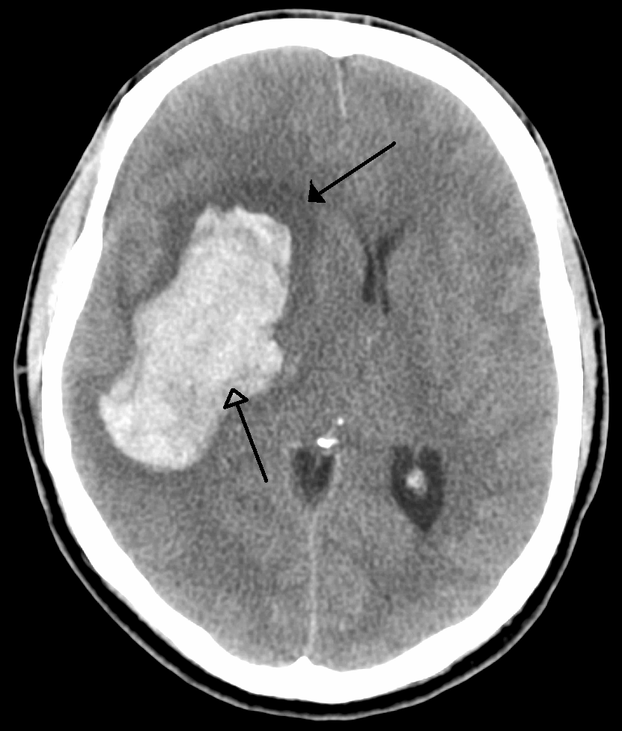

  

A nurse’s quick reference to reducing the risk

It’s all about the numbers

* Nearly 25% of strokes that occur yearly in the United States are preceded by a CVA or TIA (Bergman, 2011)
* The risk of recurrence 1 year after initial attack is 8.0% (Feng, Hendry, & Adams, 2010)
* The risk of recurrence is 30%-40% within the first 5 years after original infarct (Bergman, 2011)
* 45%-65% of strokes occur within 30 days of a TIA (Bergman, 2011)
* Risk of death within 1 year after stroke is 24.5% (Feng, Hendry, & Adams, 2010

What drugs should my patient receive at discharge?

* Antithrombolytic:
* Statin Drug
* Anticoagulant
* Antihypertensive

Don’t Forget Core Measures!

Important Lifestyle modifications

* **Smoking cessation**
  + After one year of smoking cessation, the risk of stroke drops by 50%.
  + The direct risk of stroke is related to the number of cigarrets per day the patient smokes.
  + Provide smoking cessation literature to each patient.
* **Exercise** 
  + If MD gives the okay, encourage 20-30 minutes of exercise at least 5 days per week.
  + Decreases the risk of another stroke and helps improve residual symptoms of previous stroke.
  + Decreases risk of HTN
* **Diet Modifications**
  + Lower dietary fat intake
  + Reduce salt intake (decreases BP)
  + Increased consumption of fruits and vegetables

What increases the risk of a 2nd stroke?

* **Atrial Fibriliation:** Afib is a major risk factor for stroke, making a person five times more likely to have a stroke. About 15 percent of all people who have strokes have Afib, too.
* **Hypertension:** Uncontrolled high blood pressure increases a person's stroke risk by four to six times. Over time, hypertension leads to atherosclerosis and hardening of the large arteries.

When to return the ER?

* **F:** Facial drooping.
  + Does one side of the face droop or is it numb?
* **A:** Arm weakness.
  + Is one arm weak or numb?
* **S:** Speech Difficulty.
  + Is speech slurred?
* **T:** Time to call 9-1-1.
  + Get to the hospital immediately!

